Plant Sale Procedure
Updated May 2023

Time Line:

Four months in advance –
- Confirm that Earth Day will be celebrated in Seguin as usual, confirm the date, and attend all related meetings.
- Chapter president appoints plant sale manager.
- Check with BOD to decide whether to retain last year’s setup site.
- Turn in application form to Seguin Main Street Dept.
- Review this procedure for corrections or additions

Three months in advance -
- Ask for volunteers to raise/obtain plants for the sale: consider variety, popularity, outside publicity and demand.
- Begin collecting boxes/cardboard trays for customers to use.
- Complete preliminary project funding request for estimated costs if the annual budget does not include an allowance for the sale.
- Circulate sign-up sheets with specified time slots at this and all subsequent chapter meetings to assure enough member participation.

Four weeks in advance –
- Canvas membership for species and numbers of plants they will donate.
  - Arrange for production of new plant sale signs and needed plant care cards.
- Confirm pricing strategy. Update price signs if necessary.
- Arrange to use two smart phones and The Squares to take credit card sales.
- Confirm all inventory items on hand.

Two weeks in advance –
- Finalize volunteer work schedule.
- Distribute volunteer instructions (‘Plant Sale Procedure’ and ‘Tips for Volunteers’)
- Arrange for transport of supplies and plants to the sale.

One week in advance –
- Arrange for transportation of all supplies to site.
- Arrange to collect plants if members need assistance.

Two days in advance -
- Obtain appropriate change.

Next working day –
- Sale manager, treasurer r chapter president deposits funds in chapter credit union account.

One week post sale –
- Hold after-action meeting with chapter BOD and major participants, reviewing entire process: what worked, what didn’t, how to improve.
- Update this document.
Setup and Breakdown:

Supervision, management and all decision-making for setup and breakdown will be provided by the plant sale manager. All members helping to set up will follow that person’s direction to do the following:

7:30 AM
- Unload supplies.
- Erect shelter/cover. Connect canopies with zip ties. Anchor with weights.
- Arrange tables in a rectangle with one single entrance into the open center. (See ‘Layout’)
- Erect or hang all signs, including price signs and framed copy of Texas Sales and Use Tax Permit form 01-300.
- Arrange the concrete-based sign holders, and attach plant signs.
- Set up cashier area, place chairs and the ‘hold’ tarp in interior space.
- Set up any special exhibit area (See ‘Layout’)

8:30 AM
- Plants arrive. Arrange on tables as appropriate.
- Price plants individually when exempt from pot size prices.
- Assure that every side looks interesting and approachable.
- Lay out NICE trifold, NPSOT literature, and sign-up sheet.
- Set up cashier station.
- Give each volunteer checkout slips, clipboard and pen
- The manager reviews the sales procedure with all members.

9:00 AM
- Open cashier service

1:00 PM or so
- Depending on sales volume and progress, the sale manager will determine the time to reduce all prices by half.

2:00 PM
- Begin to dismantle, pack and remove all remaining plants and all supplies.
- Cashiers and sale manager or chapter president count all funds and confirm total. Either manager or president takes charge of funds.

3:00 PM
- Sit down, remove shoes, have a glass of wine, and smile.

Inventory:
- 8 chapter-owned 6’ tables
- 2 chapter-owned canopies
- 8 1-gallon plastic jugs of water for weights
- 2-3 large plastic bottles to water plants
- Blue 4X6’ tarp to mark hold area
- 2 chairs for volunteers’ breaks
- 2 chairs for cashiers
- 2 smart phones compatible with Squares
- Two Squares for credit/debit cards
- Cash box
- $100 in change
- Tall box to hold cash box behind the table
- 2 plant sale banners
- 2015 Seguin Earth Day prize banner
- “Sun” and Shade” signs
- Thin wire
- 8.5 X 11 posters of plants, with photos, for each type, laminated
- 36 plant ID stands – wooden stakes set in concrete, with attached clips
- Misc, tools: extra clips, wire, wire-cutting pliers
- 1 box plant care cards
- 1 pack blank 3X5 cards for last-minute plant labels and ‘sold/hold’ info
- Checkout slips
- 12 small clipboards for checkout slips
- BIC pens for checkout slips and hold cards
- Zip ties
- Bungee cords
- Cardboard boxes cut down to trays (ala Costco)
- Plastic grocery bags for customers for wet pots
- Updated price signs with credit/debit card acceptance
- Framed Texas Sales and Use Tax permit form 01-300. This is a permanent form; it does not have to be reprinted or refiled every year.
- Wooden easel
- Water for members in a cooler
- 2 red wagons
- 100+ Plant labels or sticks, Sharpies for writing plant names – RT
- At least one chapter-owned copy of “Native and Adapted Landscape Plants” to show customers what the plant will look like
- Membership brochures
- Meeting announcement cards
- “Are you interested?” sheets
- NPSOT and NICE brochures/handouts
- NICE trifold
- 12 large rocks in case of wind

Sales Procedure for Volunteers
Wear NPSOT shirt and/or apron, or light-colored T shirt and NPSOT name tag.

Leave personal effects, such as purses, at home or in your vehicle.

The sales process:
- Approach and greet every potential customer with a plant tray, clipboard, checkout slips and pen in hand.
- Use the 10-second introduction.
- Answer questions, ask about needs and interests, suggest plants.
- Offer green meeting card, saying: "Our chapter meets once a month to learn from expert speakers. We also take fun field trips and do wonderful work projects. We would be delighted if you would join us. Here is information about our meetings, our web site and our Facebook page.”
- Offer to hold paid-for plants until 2PM.
- Help select plants, carry tray for customer.
- Complete checkout slip for each type of plant:
- enter plant name and maximum sizes,
- circle ‘plant in’ items,
- enter price per plant. If more than one of a single type of plant, enter the price for one plant times the number of plants: example, $6 X 4.
- Summarize accumulated prices (for multiple plants and types of plants) on the right margin of the top checkout slip.
- When customer has concluded choices, lead to cashier station.
- Give checkout slip(s) to cashier.
- Cashier will return checkout slips to customer when sale is finalized.
- If customer asks to hold plants:
  - Only plants that are paid for will be held, for customers or members.
  - Cashier helps customer fill out and place a hold card in every plant or box of plants they bought.
  - Card must include the word SOLD and the customer’s name
  - Remind customer that plants must be picked up by 2PM
  - Cashier moves plants to hold area. Customer does not enter hold area.
- Help to car if necessary
- Keep tray if possible, for re-use

The passport:

- A ‘passport’ is a pre-printed page issued by the city of Seguin. It advertises Earth Day and lists the names of all of the booths.
- When a guest presents the passport, initial the box beside the chapter’s name. While initialing, give the 10-second introduction to native plants.

The checkout slip:

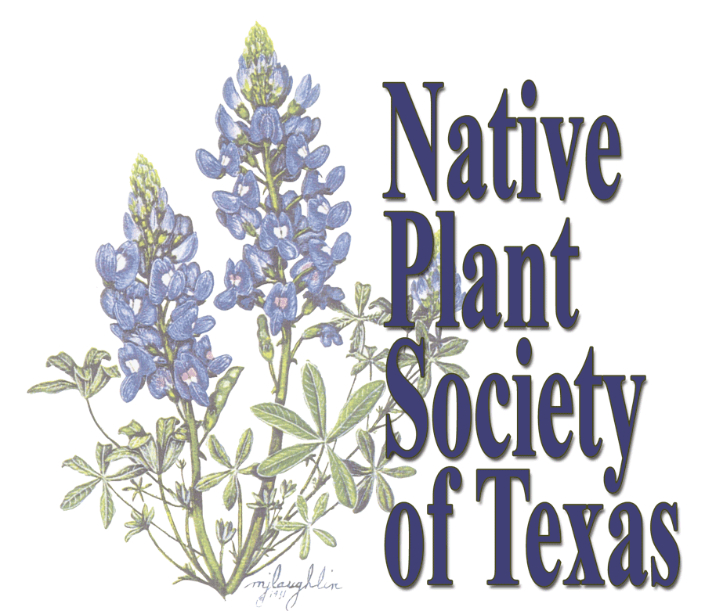 | Native Plant Society of Texas  Guadalupe Chapter  http://www.npsot.org/wp/Guadalupe

Plant Name: _________________________________
Maximum size: _______ tall _________ wide

Plant in:
sun shade part (dappled or 4 hours/day)

sand clay caliche loam

How to plant: Dig hole only as deep but twice as wide as the plant’s base. Loosen and spread the plant’s roots while refilling
the hole.

Mulch: 3 inches. Replace or add every year.
Water: Daily for 2 weeks, weekly for the next 6 months
(more often if hot and dry), then only in long dry spells.

Price: _______________________________________

*For Native Plant Guide, go to Lady Bird Johnson Wildflower Center
http://www.wildflower.org/plants/

Tips for Volunteers at the Plant Sale
The 10-second introduction:
“Hi! Come and meet some plants that are native to this part of Texas. Natives can beautify your yard, plus help the environment and our native butterflies, bees and birds. Are you looking for something to plant in a specific place?”

FAQ: Frequently Asked Questions About Native Plants:

Q: What is a ‘native plant?’ What do you mean by ‘native plant?’

A: A native plant is one that grows naturally in this area, so it needs less care and it attracts more wildlife. Most natives have been growing here since before any humans came.

Q: What other kinds of plants are there?

A: Most of the plants sold in nurseries and big stores like Home Depot, Lowe’s, and HEB are from Asia, Africa and Australia, although if you ask, they might have some natives.

A: We can suggest some local nurseries that DO sell natives.

Q: When I moved here I planted some of my favorite flowers. They died. Why?

A: Many non-native plants can’t adapt to Texas soil, drought, extreme heat, and abrupt changes in temperature. Our natives are tough!

Q: Why shouldn’t we use imported plants?

A: Native plants are accustomed to growing in this area of Texas, in its changing conditions. Many non-natives don’t do well here.

A: Birds, bees and other animals need nourishment from native plants. Many of them cannot eat or lay their eggs on imported . Imported plants simply do not give them food to live.

A: Many species of birds and insects are dying out here because there are so few native plants now.

A: Once they are established, native plants need much less care than imports.

A: Native plants are easier and less expensive to keep alive than imports.

Q: How can I tell if the plants in my yard are native plants?

A: If you find that birds and bugs hang around the flowers, eat their leaves and seeds, and if you find insect eggs on the undersides of the leaves, the plants might be natives.

Q: Do I have to replace my imported plants with natives?

A: No. Just use natives from now on.

Q: My non-native plants grow well.

A: Yes, but they won’t sustain the native bird and insect population. Most will not eat or lay their eggs on non-native plants.

Q: Birds and butterflies come to my imported plants.

A: But most imported plants can’t accommodate the entire life cycle of our native birds and insects.

A: The flowers might attract bees and hummingbirds, but very few local insects lay their eggs on imported plants, or eat their leaves.

A: Most local caterpillars, that turn into butterflies, can’t eat the leaves.

A: Many local birds eat the insects, and feed them to their babies.

A: Most local birds don’t eat the seeds that imported plants produce. Many Texas species of birds and butterflies are becoming very rare because there is nothing for them to eat.

Q: Why would I want to encourage bugs to eat my plants? Ugh!

A: Plants aren’t just decorations. They are part of the life cycle of Earth.

A: Some caterpillars that eat native plants turn into unique Texas butterflies.

A: Some unique birds eat those caterpillars and other native insects, and feed them to their babies.
Layout
North

Lar

Special display

Large plants

2015 award
native plant banner

Chairs for members
native plant banner

Hold/Sold area
Cashiers

water
Blue plastic tarp NICE
trifold

Not to scale. Every table is 6’ long

Sidewalk

Nolte Street

Cashier Station

Care cards and other handouts

Cashier

Customers set plants, write checks, fill out hold cards
Chairs
Cash
box

